Data Processing Instructions

MODULE 2

- The data processing instructions manipulate data within registers. They are move instructions, arithmetic instructions, logical instructions, compare instructions and multiply instructions.
- Most data processing instructions can process one of their operands using the barrel shifter.
- If S is suffixed on a data processing instruction, then it updates the flags in the cpsr.

MOVE INSTRUCTIONS:
- It copies N into a destination register Rd, where N is a register or immediate value. This instruction is useful for setting initial values and transferring data between registers.

Syntax: <instruction> {<cond>} {S} Rd, N
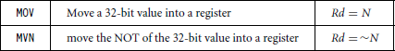
- In the example shown below, the MOV instruction takes the contents of register r5 and copies them into register r7.
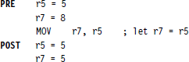

BARREL SHIFTER(USING BARREL SHIFTER WITH DATA TRANSFER INSTRUCTION
- Data processing instructions are processed within the arithmetic and logic unit (ALU).
- A unique and powerful feature of the ARM processor is the ability to shift the 32-bit binary pattern in one of the source registers left or right by a specific number of positions before it enters the ALU.
- This shift increases the power and flexibility of many data processing operations.
- For example, We apply a logical shift left (LSL) to register Rm before moving it to the destination register.
PRE r5=5 r7=8
MOV r7, r5, LSL #2 POST r5=5
r7=20
- The above example shift logical left r5=5 (00000101 in binary) by two bits and then r7=20 (00010100 in binary).

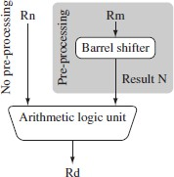
Figure: Barrel shifter and ALU
- Following table shows barrel shifter operation
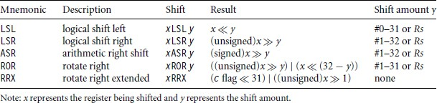
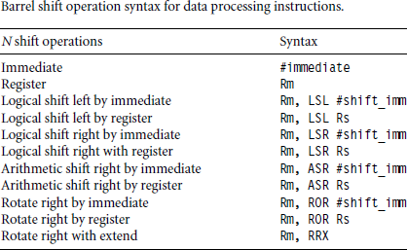

ARITHMETIC INSTRUCTIONS:
- The arithmetic instructions implement addition and subtraction of 32-bit signed and unsigned values.

Syntax: <instruction>{<cond>} {S} Rd, Rn, N
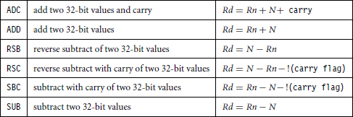
- In the following example, subtract instruction subtracts a value stored in register r2 from a value stored in the register r1. The result is stored in register r0.
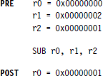
0∗0000 0000 0000 0000 0000 0000 0000 0000 ...... 0010
0∗0000 0000 0000 0000 .................................. 0001
0∗0000
- In the following example, the reverse subtracts instruction (RSB) subtract r1 from the constant value #0, writing the result in r0.

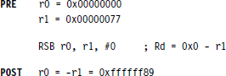

R1=0000 0000 0000 0000 0000 0000 0111 0110

-r1= 1111 1111 1111 1111 1111 1111 1000 1001(ffffff89)

USING THE BARREL SHIFTER WITH ARITHMETIC INSTRUCTIONS:
- Example below illustrates the use of the inline barrel shifter with an arithmetic instruction. The instruction multiplies the value stored in register r1 by three.
- Register r1 is first shifted one location to the left to give the value of twice r1. The ADD instruction then adds the result of the barrel shift operation to register r1. The final result transferred into register r0 is equal to three times the value stored in register r1.
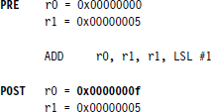

LOGICAL INSTRUCTIONS:
- Logical instructions perform bitwise operations on the two source registers.

Syntax: <instruction> {<cond>} {S} Rd, Rn, N
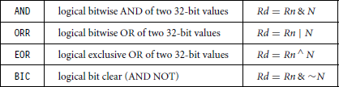
- In the example shown below, a logical OR operation between registers r1 and r2 and the result is in r0.
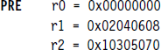
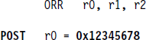

COMPARISON INSTRUCTIONS:
- The comparison instructions are used to compare or test a register with a 32-bit value. They update the cpsr flag bits according to the result, but do not affect other registers.
- After the bits have been set, the information can be used to change program flow by using conditional execution.

Syntax: <instruction> {<cond>} Rn, N
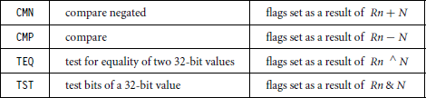
- Example shown below for CMP instruction, both r0 and r1 are equal before the execution of the instruction. The value of the z flag prior to the execution is 0 and after the execution z flag changes to 1 (upper case of Z).

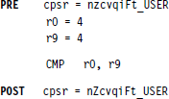
- The CMP is effectively a subtract instruction with the result discarded;
- Similarly the TST instruction is a logical AND operation and TEQ is a logical XOR operation. For each, the results are discarded but the condition bits are updated in the cpsr.

MULTIPLY INSTRUCTIONS:
- The multiply instructions multiply the contents of a pair of registers and depending upon the instruction, accumulate the results in another register.
- The long multiplies accumulate onto a pair of registers representing a 64-bit value.

Syntax: MLA {<cond>} {S} Rd, Rm, Rs, Rn MUL {<cond>} {S} Rd, Rm, Rs
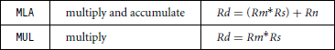
Syntax: <instruction> {<cond>} {S} RdLo, RdHi, Rm, Rs
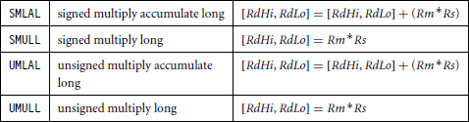
- In the following example below shows a multiply instruction that multiplies registers r1 and r2 and places the result into the register r0.
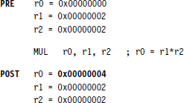
- The long multiply instructions (SMLAL, SMULL, UMLAL, and UMULL) produce a 64- bit result.
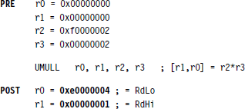

BRANCH INSTRUCTIONS
Q2. Explain briefly branch instructions of ARM processor.

Answer:
- A branch instruction changes the flow of execution or is used to call a routine.
- This type of instruction allows programs to have subroutines, if-then-else structures, and loops.
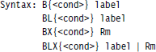
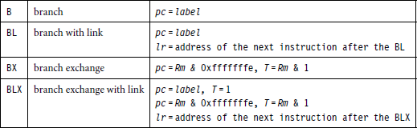
- The change of execution flow forces the program counter (pc) to point to a new address.

- T refers to the Thumb bit in the cpsr.
- When instruction set T, the ARM switches to Thumb state.
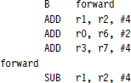
- The example shown below is a forward branch. The forward branch skips three instructions.
0*00000000
0*00000004
0*00000008
0*0000000c
0*00000010
Backward
0*00000014 Add r1,r2#4
0*00000018 Sub r1,r2,#4

0*0000001c Add r4,r6,r7

0*00000020 B backward
  - The branch with link (BL) instruction changes the execution flow in addition overwrites the link register lr with a return address. The example shows below a fragment of code that branches to a subroutine using the BL instruction.
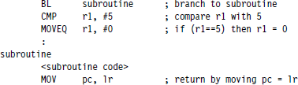
  - The branch exchange (BX) instruction uses an absolute address stored in register Rm. It is primarily used to branch to and from Thumb code. The T bit in the cpsr is updated by the least significant bit of the branch register.
  - Similarly, branch exchange with link (BLX) instruction updates the T bit of the cpsr with the least significant bit and additionally sets the link register with the return address.

LOAD-STORE INSTRUCTIONS ( Memory Access Instructions)
- Load-store instructions transfer data between memory and processor registers. There are three types of load-store instructions: single-register transfer, multiple-register transfer, and swap.

Single-Register Transfer
- These instructions are used for moving a single data item in and out of a register.
- Here are the various load-store single-register transfer instructions.

Syntax: <LDR|STR>{<cond>}{B} Rd, addressing¹ LDR{<cond>}SB|H|SH Rd, addressing² STR{<cond>}H Rd, addressing²

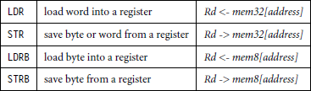
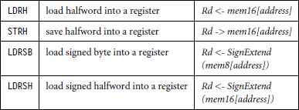

- Example:
- LDR r0, [r1]
  - This instruction loads a word from the address stored in register r1 and places it into register r0.

- STR r0, [r1]
- This instruction goes the other way by storing the contents of register r0 to the address contained in register r1.

Multiple-Register Transfer
- Load-store multiple instructions can transfer multiple registers between memory and the processor in a single instruction. The transfer occurs from a base address register Rn pointing into memory.
- Multiple-register transfer instructions are more efficient from single-register transfers for moving blocks of data around memory and saving and restoring context and stacks.

Syntax: <LDM|STM>{<cond>}<addressing mode> Rn{!},<registers>{ˆ}
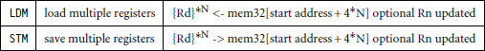

  - Here N is the number of registers in the list of registers.

SWAP Instruction
  - The swap instruction is a special case of a load-store instruction. It swaps the contents of memory with the contents of a register.

Syntax: SWP {B} {<cond>} Rd, Rm, [Rn]
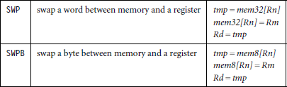
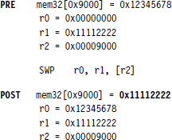

Addressing modes:
Single-Register Load-Store Addressing Modes
- The ARM instruction set provides different modes for addressing memory.
- These modes incorporate one of the indexing methods: preindex with writeback, preindex, and postindex
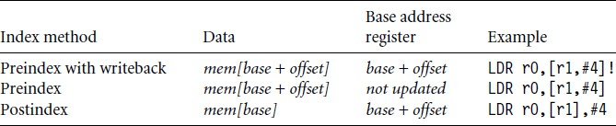

Example:
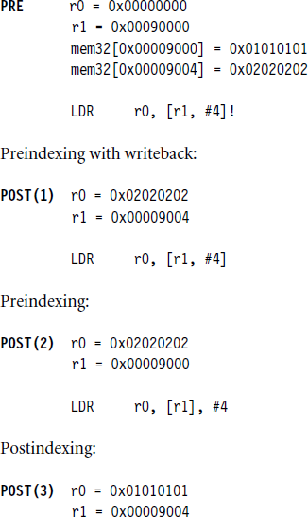
oo

Preindex with write back calculates an address from a base register plus address offset and then updates that address base register with the new address.

Preindex offset is the same as previous but does not update address of base register.
Post index only updates the address base register after the address is used.
Addressing mode for load-store multiple instructions
- Table below shows the different addressing modes for the load-store multiple instructions.
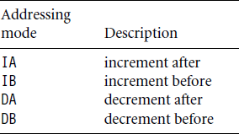

Example:
mem32[0x8001c] =0x04
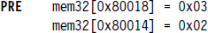
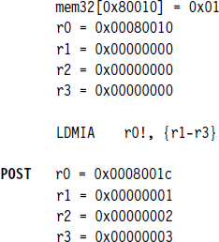

- If LDMIA is replaced with LDMIB post execution the content of registers is shown below
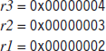

STACK OPERATIONS
  - The ARM architecture uses the load-store multiple instructions to carry out stack operations.
  - The pop operation (removing data from a stack) uses a load multiple instruction; similarly, the push operation (placing data onto the stack) uses a store multiple instruction.

  - When you use a full stack (F), the stack pointer sp points to an address that is the last used or full location.
  - In contrast, if you use an empty stack (E) the sp points to an address that is the first unused or empty location.
  - A stack is either ascending (A) or descending (D). Ascending stacks grow towards higher memory addresses; in contrast, descending stacks grow towards lower memory addresses.
  - Addressing modes for stack operation
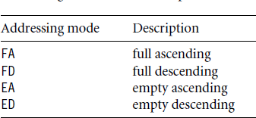
  - The LDMFD and STMFD instructions provide the pop and push functions, respectively.
  - Example1: With full descending
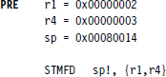
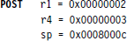
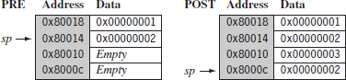

Figure: STMFD instruction full stack push operation.
Example 2: With empty descending
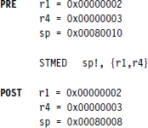
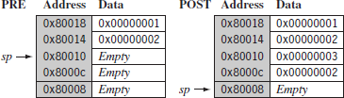
Figure: STMED instruction empty stack push operation.

SOFTWARE INTERRUPT INSTRUCTION
Q3. Explain briefly the software interrupt instruction.

Answer:
- A software interrupt instruction (SWI) causes a software interrupt exception, which provides a mechanism for applications to call operating system routines.

Syntax: SWI {<cond>} SWI_number
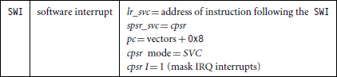
- When the processor executes an SWI instruction, it sets the program counter pc to the offset 0xB in the vector table.
- The instruction also forces the processor mode to SVC, which allows an operating system routine to be called in a privileged mode.
- Each SWI instruction has an associated SWI number, which is used to represent a particular function call or feature.
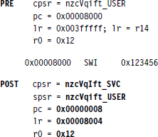
- The example below shows an SWI call with SWI number 0x123456, used by ARM toolkits as a debugging SWI.
- Since SWI instructions are used to call operating system routines, it is required some form of parameter passing.
- This achieved by using registers. In the above example, register r0 is used to pass parameter 0x12. The return values are also passed back via register.

Since SWI instructions are used to call operating system routines, you need some form of parameter passing. This is achieved using registers. In this example, register r0 is used to pass the parameter 0x12. The return values are also passed back via registers. ■
Code called the SWI handler is required to process the SWI call. The handler obtains the SWI number using the address of the executed instruction, which is calculated from the link register lr.
The SWI number is determined by
SWI_Number = <SWI instruction> AND NOT(0xff000000)
Here the SWI instruction is the actual 32-bit SWI instruction executed by the processor.
Example This example shows the start of an SWI handler implementation. The code fragment deter- 3.25 mines what SWI number is being called and places that number into register r10. You can see from this example that the load instruction first copies the complete SWI instruction into register r10. The BIC instruction masks off the top bits of the instruction, leaving the
SWI number. We assume the SWI has been called from ARM state.
SWI_handler
;
; Store registers r0-r12 and the link register
;
STMFD sp!, {r0-r12, lr}
; Read the SWI instruction
LDR r10, [lr, #-4]
; Mask off top 8 bits
BIC r10, r10, #0xff000000
; r10 - contains the SWI number BL service_routine
; return from SWI handler LDMFD sp!, {r0-r12, pc}ˆ
The number in register r10 is then used by the SWI handler to call the appropriate SWI service routine.

Program Status Register Instructions
Q4. Explain briefly program status register instructions.

Answer:
- The ARM instruction set provides two instructions to directly control a program status register (psr).
- The MRS instruction transfers the contents of either the cpsr or spsr to general purpose register.
- The MSR instruction transfers the contents of a general purpose register to cpsr or spsr.
- Together these instructions are used to read and write the cpsr and spsr.
Syntax: MRS {<cond>} Rd <cpsr |spsr>
MSR {<cond>} <cpsr|spsr} _<fields>,Rm
MSR {<cond>} <cpsr|spsr} _<fields>, #immediate
- The table shows the program status register instructions
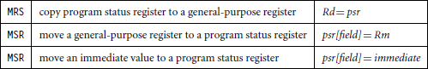

Coprocessor Instructions
Q5. Explain briefly coprocessor instructions.

Answer:
- Coprocessor instructions are used to extend the instruction set.
- A coprocessor can either provide additional computation capability or be used to control the memory subsystem including caches and memory management.
- These instructions are used only by core with a coprocessor.
Syntax: CDP {<cond>} cp,opcode1, Cd, Cn {,opcode2}
<MRC|MCR>{<cond>}cp,opcode1,Rd,Cn,Cm{,opcode2}
<LDC|STC>{<cond>}cp,Cd,addressing
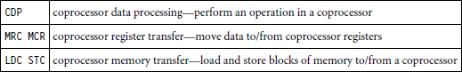
- In the syntax of the coprocessor instructions, the cp field represents the number between p0 and p15. The opcode fields describe the operation to take place on the coprocessor. The Cn, Cm and Cd fields describe registers within the coprocessor.
- For example: The instruction below copies coprocessor CP15 register c0 into a general purpose register r10.
MRC p15, 0, r10, c0, c0, 0 ; CP15 register-0 is copied into general purpose register r10.
- For example: The instruction below moves the contents of CP15 control register c1 into register r1 of the processor core.
MRC p15, 0, r1, c1, c0, 0

Loading Constants
Q6. Explain briefly the loading constants.

Answer:
- There are two pseudo instructions to move a 32-bit constant value to a register. Syntax: LDR Rd, =constant
ADR Rd, label

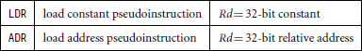
- The example below shows an LDR instruction loading a 32-bit constant 0xff00ffff into register r0.
LDR r0, =0xff00ffff

Programs:
- Write ALP program for ARM7 demonstrating the data transfer.

Answer:
AREA DATATRANSFER, CODE, READONLY ENTRY
LDR R9,=SRC ;LOAD STARTING ADDRESS OF SOURCE
LDR R10,=DST ;LOAD STARTING ADDRESS OF DESTINATION

LDMIA R9!,{R0-R7] STMIA R10!,{R0-R7]

SRC DCD 1,2,3,4,5,6,7,8
AREA BLOCKDATA, DATA, READWRITE DST DCD 0,0,0,0,0,0,0,0
END
- Write ALP program for ARM7 demonstrating logical operation. Answer:
AREA LOGIC, CODE, READONLY ENTRY
LDR R0, =5
LDR R1, =3 AND R4, R0, R1 ORR R5, R0, R1 EOR R6, R0, R1 BIC R7, R0, R1 END

- Write ALP program for ARM7 demonstrating arithmetic operation. Answer:
AREA ARITH, CODE, READONLY ENTRY
LDR, R1, =20
LDR R2, =25 ADD R3, R1, R2 MUL R4, R1, R2 SUB R5, R1, R2 END

- Write ALP using ARM instructions that calls subroutine fact to find factorial of a given number.
Answer:

AREA FACTORIAL, CODE, READONLY ENTRY
START LDR R0, #5
BL FACT // BRANCH WITH LINK LDR R4, =DST // LOCATION TO STORE RESULT STR R5, [R4]
STOP B STOP

FACT

LOOP
MOVS R1, R0 ; If R1= 0, ZF =1 MOVEQ R5, #1 ; If ZF =1, Return 1

SUBNES R1, R1, #1 ; R1 = R1-1 if R1 not 0 MULNE R0, R1, R0 ; R0 = R1 * R0
BNE LOOP ; IF (R1 != 0) LOOP.
MOV R5, R0
MOV PC, R14 ; RETURN WITH RESULT IN R5.
AREA FACT, DATA, READWRITE DST DCD 0
END

- Write ALP program to add array of 16 bit numbers and store the result in memory. Answer:
AREA AryAdd, CODE, READONLY ENTRY
LDR R0, =SRC ; pointer to source array LDR R1, = DST ; pointer to destination MOV R2, #5 ; count of numbers MOV R5, #0 ; initial sum
UP LDRH R3, [R0] ; 1st number in R2 ADD R5, R5, R3 ; add numbers
ADD R0, R0, #2 ; increment pointer to next number SUBS R2, R2, #1 ; decrement count by 1 CMP R2, #0
BNE UP STRH R5, [R1]
STOP B STOP
SRC DCW 10, 20, 30, 40, 50
AREA BLOCKDATA, DATA, READWRITE DST DCW 0
END

